**DOCUMENTATION- LAB 6 Sanjana R (285)**

Development of an Interactive UI Prototype Using Rapid Application Development (RAD) Model

**Objective:**

To simulate the lifecycle stages of UI design using the RAD model and to develop a small interactive interface using Axure RP.

**Model Used:**

**Rapid Application Development (RAD) Model**

I have adopted the **RAD model** for this project to facilitate rapid prototyping and iterative user feedback. The RAD model consists of four key phases:

**Phase 1: Requirements Planning**

I began by gathering requirements and identifying the essential features of the interface.

Key features identified included:

-> Navigation: Home, Product Categories, Product Details, Cart, Checkout, Order Confirmation, Order History

-> User actions: Browsing, Searching, Adding to Cart, Checkout, Tracking Orders

**Phase 2: User Design**

-> For the design phase, I used Axure RP, a professional UI/UX wireframing tool.

-> Using the built-in widget library, I designed wireframes for key screens:

* + Home Page
  + Product Listings
  + Product Details
  + Shopping Cart
  + Checkout Process
  + Order Confirmation and History
* Basic interactions (e.g., OnClick events) were added to simulate navigation between pages.
* Masters were used to create reusable components like headers and footers.
* Annotations were added to explain the functionality and purpose of each UI element.

**Phase 3: Construction**

* I transformed static wireframes into interactive prototypes.
* Dynamic panels and transitions were added to create popups, carousels, and interactive buttons.
* The prototype was previewed and tested with stakeholders, and iterative changes were made based on feedback.

**Phase 4: Cutover**

* Once finalized, the prototype was exported and shared using **Axure Cloud**.
* A basic user guide was created to walk users through the interface.
* Support and documentation were prepared for future reference.

**Tools Used:**

* **Axure RP** for wireframing and prototyping
* **RAD model** for structured and iterative development

**Conclusion:**

By using the RAD model, I was able to involve stakeholders early and throughout the UI development process, ensuring the final design was aligned with user expectations. The use of Axure RP enabled rapid prototyping and easy testing of UI flows.

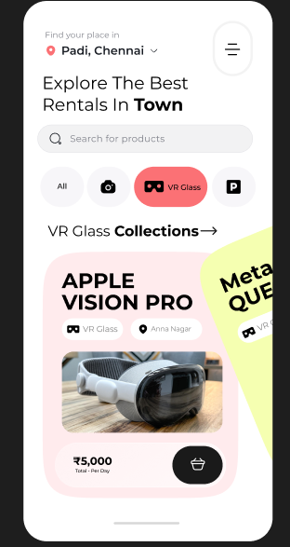

Detailed product description

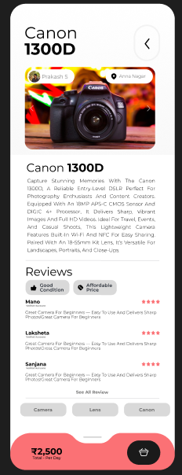

Detailed checkout page

